# GAEB Converter installation steps:

Download Link: [www.download.t-t.de/gaeb-konverter-v9-setup.exe](http://www.download.t-t.de/gaeb-konverter-v9-setup.exe)

1. Copy and paste the link in browser and press enter.

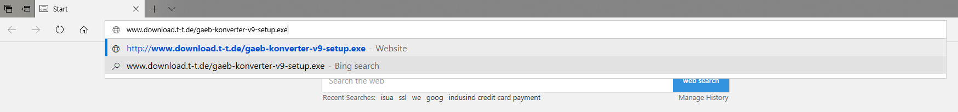

1. Then the installer will be downloaded.



1. Open the download folder and double click to install.

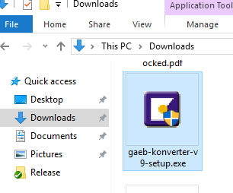

1. Below screen will be appeared, click on next.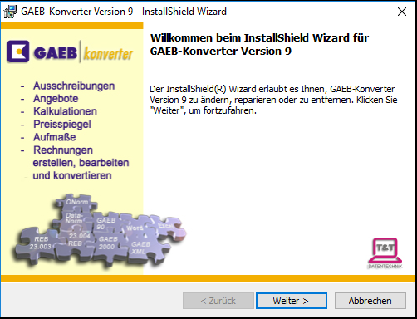
2. Click on next.

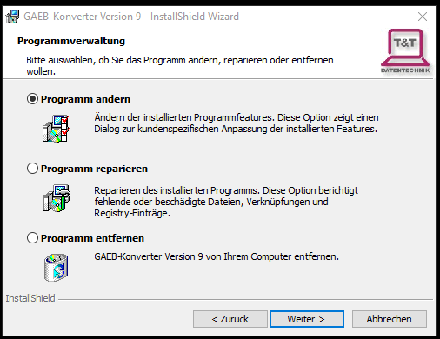

1. Click on next.

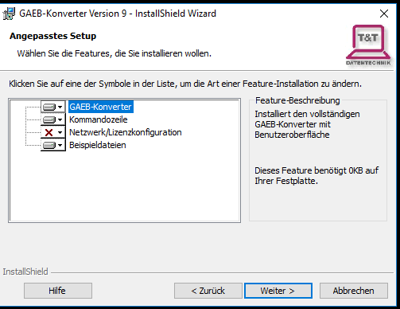

1. Click on Install.

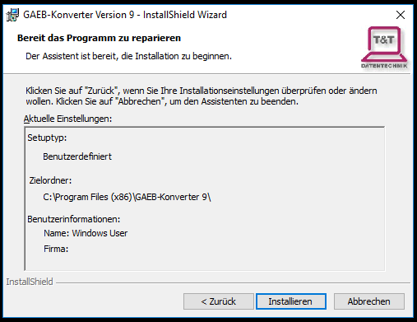

1. Click on finish.

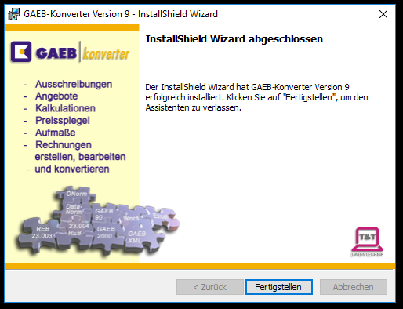

Finally the small will get closed. Now try to import an GAEB file.